## NAME:S.Logitha

REG NO:192121138

**18.USING RAPTOR –SWAP 2 NUMBER**

**FLOWCHART**

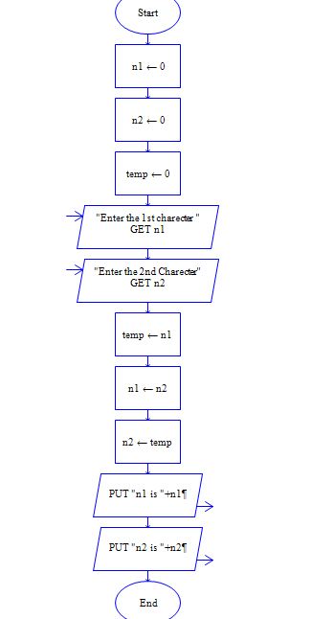

**INPUT**

N1 = 11

N2 = 25

**OUTPUT**

